
Applikationsbericht / Application Report
Applikation: Application: | CLV 6xx Commands
Bearbeiter: Editor: | Guenter Kluemper  Applikation Div05 | Phone:  Fax:  E-Mail: | +49 (0) 76 41-4 69-1706  +49 (0) 76 41-4 69-1290  Guenter.Kluemper@sick.de | 28. Jan 2011
Verteiler:
Copy to:

Content:

1. General structure of SOPAS-Telegramm 2
2. Error handling 3
3. Control of Outputs direct at CLV 6xx (cable version) using commands 4
4. Control of External Outputs at CLV 6xx with CMC 600 5
5. Reading of Inputs and Outputs of CLV 6xx 6
6. Register Inputs and Outputs of CLV 6xx 7
7. Change Codeconfig, Sample 1: 9
8. Change Codeconfig, Sample 2: 11
9. Set Matchcode at direct connected Scanner using Sopas Command: 13
10. Set Matchcode in CAN-Network using Sopas Hub-Commands: 13
11. SW-Trigger via CAN-Bus using Sopas Hub-Commands: 14
12. SW-Trigger using Sopas ET: 16
12.1 Trigger as 21/22 without echo 18
12.2 Trigger as 21/22 with echo 18
12.3 Trigger via Sopas Commands 19
13. Readout of Operating Data via Commands: 20
14. List of usefull commands: 21
15. Short form Non-Sopas commands for Matchcodes (CLV 6xx V3.20 or higher): 22
16. Handling of variables from type “Real” and “LReal”: 24

General structure of SOPAS-Telegramm

Each SOPAS Telegramm includes
- the TYP of the request (e.g. sMN),
- the Name of the Methode/Variable and
- the Parametern.

The type indicates wheather the request is a Variable, a Method or an Event.
The first character is always the lower case „s“.
SOPAS-Commands are always framed with STX/ETX.

SOPAS-Telegram (for sending)
[STX]sWN FTScanFrq 10[ETX]
N: Access by Name (Standard)
I: Access by Index (do not use!)

R: read access of a Variable
W: write access of a Variable
M:call a Method
E:activate/deactivate an Event (Aktivieren/Deaktivieren)
Name of the Variable/the Method/the Event
Value of the Parameter (if available)

SOPAS-Telegram (receiving)
[STX]sAN SetAccessMode 1[ETX]
Return value (if available)

Name of the Variable/the Method/the Event

N: Access by Name (Standard)
I: Access by Index (do not use!)
A:Answer of reding, writing or confirmation

R: read access of a Variable
W: write access of a Variable
M:acknowlegement of Method (followed by others)
A:Answer to a Method
E:activate/deactivate an Event
S:Event (with content)

Error handling

If an error occurs the Sopas command is answered with:

[STX]sFA <x>[ETX] as an error response

Error list: <x> can have following values:
1: Access denied
2: Unknown Index
3: Unknown Index
4: Wrong Condition
5: Invalid Data
6: Unknown Error
7: Too Many Parameter
8: Parameter Missing
9: Wrong Parameter
A: No Write Access
B: Unknown Command
C: Unknown Command
D: Server Busy
E: Textstring Too Long
F: Unknown Event
10: Too many Parameter
11: Invalid Character
12. No Message
13: No Answer
14: Internal Error
15: HubAddress: wrong
16: HubAddress: error
17: HubAddress: error

Control of Outputs direct at CLV 6xx (cable version) using commands

Use only cable version and not Ethernet-Version !

Parametration: Outputs must be set to Command
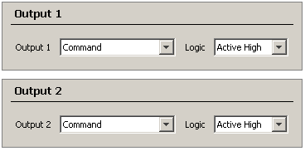
Command:
[STX]sMNmDOSetOutput 2 1[ETX]
[STX] Start char, Hex 02
sMN Sopas Method by Name
mDOSetOutput Command for digital output of CLV 6xx
space for separation
- Output No 2, (or Output No 1)
space for separation
- 1 = Output is set, 0 = Output is reset
[ETX] Stop char, Hex 03

Answer of command:
[STX]sAN mDOSetOutput 1[ETX] (positive)
[STX]sAN mDOSetOutput 0[ETX] (negative, e.g when an Ethernet version is used, or when output is not set to be controlled via command)
Command:
[STX]sMNmDOSetOutput 1 1[ETX] Sets Output No 1
[STX]sMNmDOSetOutput 1 0[ETX] Resets Output No 1

[STX]sMNmDOSetOutput 2 1[ETX] Sets Output No 2
[STX]sMNmDOSetOutput 2 0[ETX] Resets Output No 2
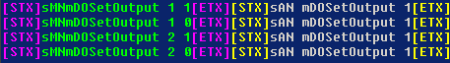
Test with See-It:

Control of External Outputs at CLV 6xx with CMC 600

Works with both Cable and Ethernet-Version, but a CMC 600 must be installed !!!

Parametration: External Outputs must be set to Command
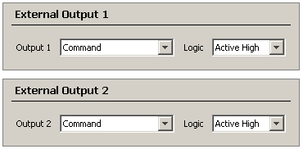
Command:
[STX]sMNmEOSetOutput 2 1[ETX]
[STX] Start char, Hex 02
sMN Sopas Method by Name
mEOSetOutput Command for external digital output of CLV 6xx
space for separation
2 External Output No 2, (or External Output No 1)
space for separation
1 1 = Output is set, 0 = Output is reset
[ETX] Stop char, Hex 03

[STX]sMNmEOSetOutput 1 1[ETX] Sets External Output No 1
[STX]sMNmEOSetOutput 1 0[ETX] Resets External Output No 1

[STX]sMNmEOSetOutput 2 1[ETX] Sets External Output No 2
[STX]sMNmEOSetOutput 2 0[ETX] Resets External Output No 2

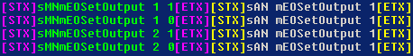
Test with See-It:

Reading of Inputs and Outputs of CLV 6xx

Command: [STX] sRN eIN1[ETX] reads first digital Input (Sensor1)
[STX] Start char, Hex 02
sRN Sopas Read by Name
space for separation
eIN1 Command for first digital input (sensor 1) of CLV 6xx
[ETX] Stop char, Hex 03

Answer: [STX]sRA eIN1 8DB22 B114 0[ETX] answer of clv 6xx
[STX] Start char, Hex 02
sRA Sopas Read Answer
space for separation
eIN1 Command for first digital input of CLV 6xx
space for separation
8DB22 additional value for inc / timestamp, can vary in content and length
space for separation
B114 additional value for inc / timestamp, can vary in content and length
space for separation
0 ➔ State of Sensor1: 0 or 1
[ETX] Stop char, Hex 03

List of all readable in and outputs:
[STX]sRN eIN1[ETX] ➔ Sensor 1
[STX]sRN eIN2[ETX] ➔ Sensor 2 (only at standard cable version of CLV 6xx)
[STX]sRN eResult1[ETX] ➔ Result 1 (only at standard cable version of CLV 6xx)
[STX]sRN eResult2[ETX] ➔ Result 2 (only at standard cable version of CLV 6xx)
[STX]sRN eExtIn1[ETX] ➔ External Input 1 (only at CMC / CDF 600)
[STX]sRN eExtIn2[ETX] ➔ External Input 2 (only at CMC / CDF 600)
[STX]sRN eExtOut1[ETX] ➔ External Output 1 (only at CMC / CDF 600)
[STX]sRN eExtOut2[ETX] ➔ External Output 2 (only at CMC / CDF 600)
[STX]sRN eReadingGate[ETX]

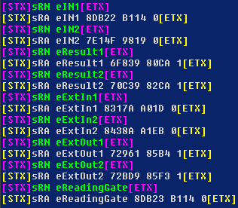
Test with See-It: CLV 6xx cable version with CMC 600:

Register Inputs and Outputs of CLV 6xx

Instead of polling the inputs as described you can get register an input or output. Than you get a message when the state of these in- or outputs has changed.

Command: [STX] sEN eIN1 1[ETX] register first digital Input (sensor1)
[STX] Start char, Hex 02
sEN Sopas register Event by Name
space for separation
eIN1 Command for first digital input (sensor 1) of CLV 6xx
space for separation
1 set register to active (0 = sets register back to inactive)
[ETX] Stop char, Hex 03

Answer: [STX]sEA eIN1 1[ETX] answer of clv 6xx
[STX] Start char, Hex 02
sEA Sopas Event Anwer
space for separation
eIN1 Command for first digital input (sensor 1) of CLV 6xx
space for separation
1 register status
[ETX] Stop char, Hex 03

When registered this string is send when the in/output has changed:
[STX]sSN eIN1 8DB22 B114 0[ETX] answer of clv 6xx
[STX] Start char, Hex 02
sSN Sopas State by Name
space for separation
eIN1 Name of the in / output
space for separation
8DB22 additional value for inc / timestamp, can vary in content and length
space for separation
B114 additional value for inc / timestamp, can vary in content and length
space for separation
- ➔ State of in / output: 0 or 1
[ETX] Stop char, Hex 03

List of all in and outputs which can be registered:
[STX]sRN eIN1[ETX] ➔ Sensor 1
[STX]sRN eIN2[ETX] ➔ Sensor 2 (only at standard cable version of CLV 6xx)
[STX]sRN eResult1[ETX] ➔ Result 1 (only at standard cable version of CLV 6xx)
[STX]sRN eResult2[ETX] ➔ Result 2 (only at standard cable version of CLV 6xx)
[STX]sRN eExtIn1[ETX] ➔ External Input 1 (only at CMC / CDF 600)
[STX]sRN eExtIn2[ETX] ➔ External Input 2 (only at CMC / CDF 600)
[STX]sRN eExtOut1[ETX] ➔ External Output 1 (only at CMC / CDF 600)
[STX]sRN eExtOut2[ETX] ➔ External Output 2 (only at CMC / CDF 600)
[STX]sRN eReadingGate[ETX]

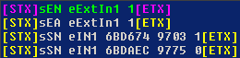
Test with See-It: CLV 6xx cable version with CMC 600:

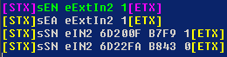
Registered and additional an change of the inputs:
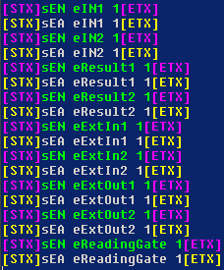

Only register:

Change Codeconfig, Sample 1:

Task:
- Select 2/5-Interleaved with Multiread of 5 and allow only the following length:
14 char length with Check Digit = Modulo 10,
10 char length with Check Digit = W49M10,
8 char length without Check Digit Test
- Switch off EAN / UPCA,

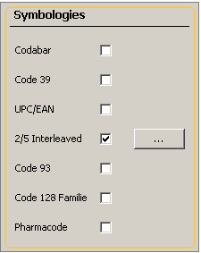
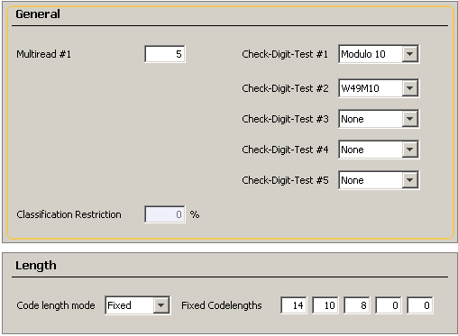

Command: (comments) Answer:

[STX]sRI0[ETX] [STX]sRA 0 6 CLV62x 10 V2.00-07.12.2007[ETX]
(to see what scanner is connected)

[STX]sMI 0 03 F4724744[ETX] [STX]sAI 0 1[ETX]
(Login as client)

[STX]sWN DCC25ILAct 1[ETX] [STX]sWA DCC25ILAct[ETX]
(activate 2/5-Interleaved)

[STX]sWN DCC25ILLenMode 2[ETX] [STX]sWA DCC25ILLenMode[ETX]
(set to fix length)
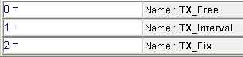
Values for Length mode: 0, 1, 2:

[STX]sWN DCC25ILFixLen E A 8 0 0[ETX] [STX]sWA DCC25ILFixLen[ETX]
(set length of 14, 10 an 8, command uses hex-values)

[STX]sWN DCC25ILMrL1 5[ETX] [STX]sWA DCC25ILMrL1[ETX]
(set multiread to 5)

[STX]sWN DCC25ILCdTstL1 1[ETX] [STX]sWA DCC25ILCdTstL1[ETX]
(set checkdigit for first length to Modulo10)

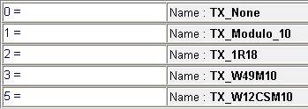
Values for Check digit mode: 0, 1, 2, 3, 5:

[STX]sWN DCC25ILCdTstL2 3[ETX] [STX]sWA DCC25ILCdTstL2[ETX]
(set checkdigit for secondt length to W49M10)

[STX]sWN DCC25ILCdTstL3 0[ETX] [STX]sWA DCC25ILCdTstL3[ETX]
(set checkdigit for thirth length to none)

[STX]sWN DCUPCEANAct 0 [ETX] [STX]sWA DCUPCEANAct[ETX]
(deactivate EAN / UPC)

[STX]sMN mEEwriteall[ETX] [STX]sMN mEEwriteall 1[ETX]
(optional: save all parameter permanent”)

[STX]sMI 2[ETX] [STX]sAI 2 1[ETX]
(Logout)

Result using See-It:
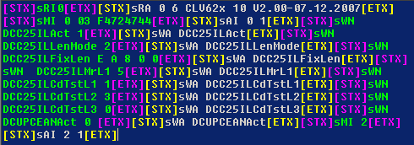

Change Codeconfig, Sample 2:

Task:
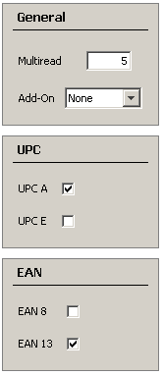
- Switch off 2/5-Interleaved,
- Select EAN 13 and UPCA with Multiread = 5.
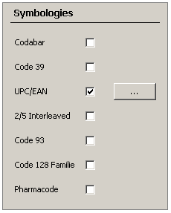

Command: (comments) Answer:

[STX]sRI0[ETX] [STX]sRA 0 6 CLV62x 10 V2.00-07.12.2007[ETX]
(to see what scanner is connected)

[STX]sMI 0 03 F4724744[ETX] [STX]sAI 0 1[ETX]
(Login as client)

[STX]sWN DCUPCEANAct 1 [ETX] [STX]sWA DCUPCEANAct[ETX]
(activate UPC/EAN)

[STX]sWN DCUPCEANMr 5[ETX] [STX]sWA DCUPCEANMr[ETX]
(set Multiread to 5)

[STX]sWN DCUPCAAct 1[ETX] [STX]sWA DCUPCAAct[ETX]
(activate UPC A)

[STX]sWN DCUPCEAct 0[ETX] [STX]sWA DCUPCEAct[ETX]
(deactivate UPC E)

[STX]sWN DCEAN8Act 0[ETX] [STX]sWA DCEAN8Act[ETX]
(deactivate EAN 8)

[STX]sWN DCEAN13Act 1[ETX] [STX]sWA DCEAN13Act[ETX]
(activate EAN 13)

[STX]sWN DCC25ILAct 0[ETX] [STX]sWA DCC25ILAct[ETX]
(deactivate 2/5-Interleaved)

[STX]sMN mEEwriteall[ETX] [STX]sMN mEEwriteall 1[ETX]
(optional: save all parameter permanent”)

[STX]sMI 2[ETX] [STX]sAI 2 1[ETX]
(Logout)

Result using See-It:
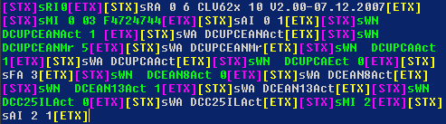

Set Matchcode at direct connected Scanner using Sopas Command:

Comunication test (optional):
Host: [STX]sRI0[ETX]
CLV: [STX]sRA 0 6 CLV62x 11 V2.40a-aa.04.2008[ETX]

Login as client:
Host: [STX]sMI 0 03 F4724744[ETX]
CLV: [STX]sAI 0 1[ETX]

Set Matchcode Match123 to "55443": (one space between each block)
Host: [STX]sMN mEVSetMatchCode 0040 name="Match123" content="55443*" length="11"
codeType="dontCare"[ETX]
CLV: [STX]sAN mEVSetMatchCode 1[ETX]

optional: save all parameter permanent:
Host: [STX]sMN mEEwriteall[ETX]
CLV: [STX]sMN mEEwriteall 1[ETX]

Logout:
Host: [STX]sMI 2[ETX]
CLV: [STX]sAI 2 1[ETX]

Result in Sopas: Evaluation Condition:

Set Matchcode in CAN-Network using Sopas Hub-Commands:

CAN-Network with two scanners:
Scanner 07 is Multiplexer → The serial Host-Port of this scanner is connected to the Host
Scanner 04 is Server

In a CAN-Network all scanners can be adressed using a Sopas Hub-Aderess in front of each command. Also the answer has the same Hub-Adress in front of it.

Sopas Hub Command:

{ 00 01 04}
{ Identifier for Hub-Aadress, hex 7B
blank for separation
00 fix 00
blank for separation
01 fix 01, because we just want to go to one additional device
blank for separation
04 ID of the adressed scanner, here scanner 04
} End of Hub-Aadress, hex 7D

These commands must be send from the Host to the scanner to set the matchcode:

Comunication test (optional):
Host: [STX]s{ 00 01 04}RI0[ETX]
CLV: [STX]s{ 00 01 04}RA 0 6 CLV62x 10 V2.40-10.04.2008[ETX]

Login as client:
Host: [STX]s{ 00 01 04}MI 0 03 F4724744[ETX]
CLV: [STX]s{ 00 01 04}AI 0 1[ETX]

Set Matchcode Match123 to "04443": (one space between each block)
Host: [STX]s{ 00 01 04}MN mEVSetMatchCode 0040 name="Match123" content="04443*" length="11" codeType="dontCare"[ETX]
CLV: [STX]s{ 00 01 04}AN mEVSetMatchCode 1[ETX]

Logout:
Host: [STX]s{ 00 01 04}MI 2[ETX]
CLV: [STX]s{ 00 01 04}AI 2 1[ETX]

Result in Sopas: Evaluation Condition:
Result using See-It:

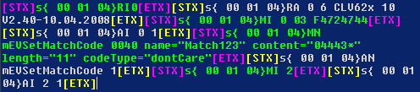

SW-Trigger via CAN-Bus using Sopas Hub-Commands:

Example with 3 Scanner CLV 6xx at ID 01, 02 and 03 running in CAN-Bus as Multiplexer / Server.
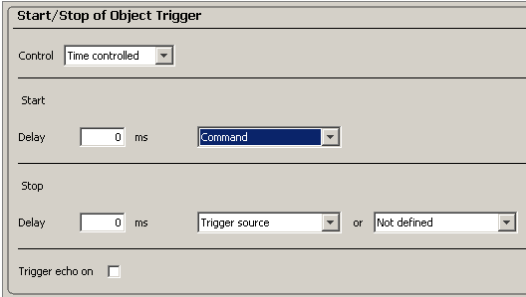
All scanners are programmed to trigger via Command. All scanner should be triggered separately.

Multiplexer Scanner (ID 01) itself: (here no Hub adress is used)
Trigger ON:
Host: [STX]sMN mTCgateon[ETX]
CLV: [STX]sAN mTCgateon 1[ETX]

Trigger Off:
Host: [STX]sMN mTCgateoff[ETX]
CLV: [STX]sAN mTCgateoff 1[ETX]
CLV: [STX]01} 1234567890[ETX] (read result)

Scanner ID 02
Trigger ON:
Host: [STX]s{ 00 01 02}MN mTCgateon[ETX]
CLV: [STX]s{ 00 01 02}AN mTCgateon 1[ETX]

Trigger Off:
Host: [STX]s{ 00 01 02}MN mTCgateoff[ETX]
CLV: [STX]s{ 00 01 02}AN mTCgateoff 1[ETX]
CLV: [STX]02} 1234567890[ETX] (read result)

Scanner ID 03
Trigger ON:
Host: [STX]s{ 00 01 03}MN mTCgateon[ETX]
CLV: [STX]s{ 00 01 03}AN mTCgateon 1[ETX]

Trigger Off:
Host: [STX]s{ 00 01 03}MN mTCgateoff[ETX]
CLV: [STX]s{ 00 01 03}AN mTCgateoff 1[ETX]
CLV: [STX]02} 1234567890[ETX] (read result)

Scanner ID 10 dec (here ID must be written in hex).
Trigger ON:
Host: [STX]s{ 00 01 0A}MN mTCgateon[ETX]
CLV: [STX]s{ 00 01 0A}AN mTCgateon 1[ETX]

Trigger Off:
Host: [STX]s{ 00 01 0A}MN mTCgateoff[ETX]
CLV: [STX]s{ 00 01 0A}AN mTCgateoff 1[ETX]
CLV: [STX]10} 1234567890[ETX] (read result)

Commandlist:
[STX]sMN mTCgateon[ETX]
[STX]sMN mTCgateoff[ETX]
[STX]s{ 00 01 02}MN mTCgateon[ETX]
[STX]s{ 00 01 02}MN mTCgateoff[ETX]
[STX]s{ 00 01 03}MN mTCgateon[ETX]
[STX]s{ 00 01 03}MN mTCgateoff[ETX]
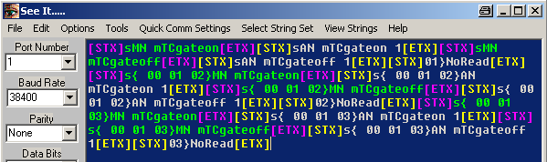
Using See-It:

SW-Trigger using Sopas ET:

Softwaretrigger at CLV 6xx

Parametrize the scanner to be triggered via command:
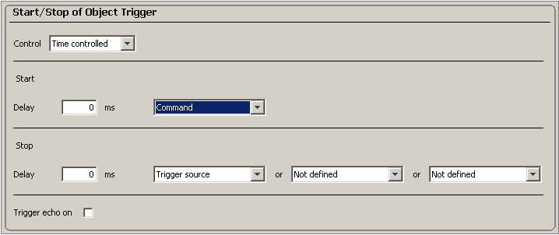

Please use the terminal emulator and connect it to the scanner .
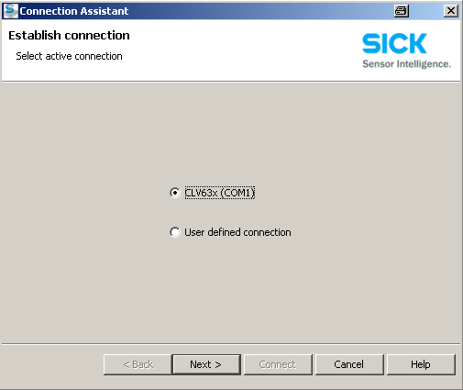

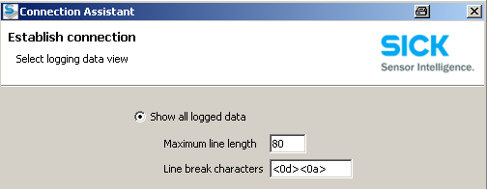
Chose than this option:

12.1 Trigger as 21/22 without echo
Here the option "trigger echo on" is NOT activated. The command do not have than an echo.

Than you can type in the commands like "21" for trigger start and "22" for trigger stop. The commands are send by pressing Enter or use the green send button at the end.
The data are automatically framed with STX / ETX.

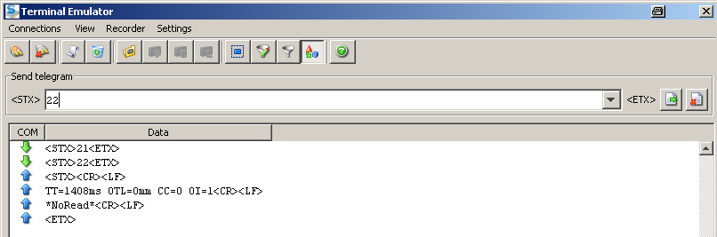

12.2 Trigger as 21/22 with echo
Here the option "trigger echo on" is activated. The command do have than an echo.


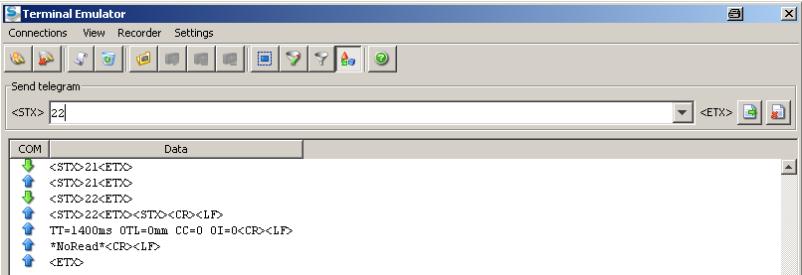

12.3 Trigger via Sopas Commands

You can also use the original Sopas commands to trigger the scanner. These commands do all times have an echo.

sMN mTCgateon ==> Trigger start
sMN mTCgateoff ==> Trigger stop

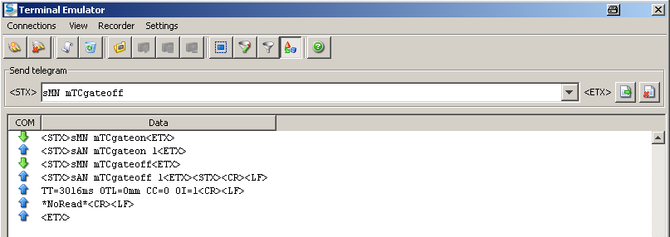

Readout of Operating Data via Commands:

In Sopas ET at Service / Operating Data the following data are displayed:

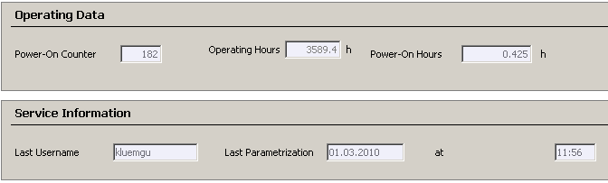
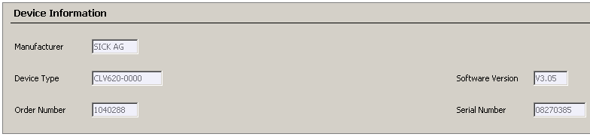
The data can be also queried using the following commands:

Host: [STX]sRN DImanf[ETX] (Manufacturer)
CLV: [STX]sRA DImanf 7 SICK AG[ETX] (7 char, content "SICK AG")

Host: [STX]sRN DItype[ETX] (Device Type)
CLV: [STX]sRA DItype B CLV620-0000[ETX] (Length = Bhex = 11dec)

Host: [STX]sRN DIornr[ETX] (Order Number)
CLV: [STX]sRA DIornr 1040288[ETX]

Host: [STX]sRN FirmwareVersion[ETX] (Software Version)
CLV: [STX]sRA FirmwareVersion 5 V3.05[ETX]

Host: [STX]sRN SerialNumber[ETX] (Serial Number)
CLV: [STX]sRA SerialNumber 8 08270385[ETX]

Host: [STX]sRN ODpwrc[ETX] (Power-On Counter)
CLV: [STX]sRA ODpwrc B6[ETX] (B6hex = 182dec)

Host: [STX]sRN ODoprh[ETX] (Operating Hours)
CLV: [STX]sRA ODoprh 8C36[ETX] (8C36hex = 35894dec x 0,1h)

Host: [STX]sRN ODopdaily[ETX] (Operating Hours since Power on)
CLV: [STX]sRA ODopdaily 3EDDDDE5[ETX] (IEEE-754 single precision, 32 bit, float)

Host: [STX]sRN DIuser[ETX] (Last Username)
CLV: [STX]sRA DIuser 7 kluemgu[ETX]

Host: [STX]sRN DIpara[ETX] (Last Parametrization Date)
CLV: [STX]sRA DIpara A 01.03.2010[ETX]

Host: [STX]sRN DIparatm[ETX] (Last Parametrization Time)
CLV: [STX]sRA DIparatm 5 11:56[ETX]

List of usefull commands:

Comunication test: (shows version of Sopas JAR/SDD file)
Host: [STX]sRI0[ETX]
CLV: [STX]sRA 0 6 CLV63x 10 V3.00-14.05.2009[ETX]

Read Location Name: (This name is displayed when searching with Sopas for a device)
Host: [STX]sRN LocationName[ETX]
CLV: [STX]sRA LocationName 6 CAN_12[ETX] (here 6 char, content "CAN_12")

Read Firmwareversion: (shows the real firmware version of the device)
Host: [STX]sRN FirmwareVersion[ETX]
CLV: [STX]sRA FirmwareVersion 5 V3.05[ETX]

Login as client: (using Index)
Host: [STX]sMI 0 03 F4724744[ETX]
CLV: [STX]sAI 0 1[ETX]

Login as client: (using name command)
Host: [STX]sMN SetAccessMode 03 F4724744[ETX]
CLV: [STX]sAN SetAccessMode 1[ETX]

Set to factory default: (All parameters are set to default !)
Host: [STX]sMN mSCloadfacdef [ETX]
CLV: [STX]sAN mSCloadfacdef[ETX]

save all parameters permanent:
Host: [STX]sMN mEEwriteall[ETX]
CLV: [STX]sMN mEEwriteall 1[ETX]

Logout: (using Index)
Host: [STX]sMI 2[ETX]
CLV: [STX]sAI 2 1[ETX]

Logout: (using name command)
Host: [STX]sMN Run[ETX]
CLV: [STX]sAN Run 1[ETX]

In general the name commands should be used, but index commands with the index 0 to 7 are also identical at all Software-Versions and may be used as shorter alternative.

Short form Non-Sopas commands for Matchcodes (CLV 6xx V3.20 or higher):

This command is accepted at all interfaces (Ser-Aux, Ser-Host, Eth-Aux, Eth-Host) of CLV 6xx.

Format of the non sopas command for defining Matchodes:

Example: <STX> 2 MC 1 0 b barcode * <ETX> (no blanks in between !)

Explanation of the positions within the command:

<STX> Header character (always <STX> !)

2 Command Identifier character (always 2)
2: commands which can be handled without login/logout

MC This commands defines a match condition (Always 'MC')

- Defines if the name of the match condition:
Valid numbers: 1 .. 9
1: Condition name = Match1
2: Condition name = Match2
...
9: Condition name = Match9

The condition name "Matchx" must already be defined in the CLV

- Defines if the condition must be stored permanently:
0: don't store permanently
1: store permanently

b: Barcode Type Identification character (CodeID)
b: Code 39
e: 2/5-Interleaved
...
*: Barcode type is 'don't care' and won't be checked

barcode Content of the machcode.
The length of the matchcode is according to number of characters here.

* If the last character of the barcode is '*' then the length of the matchcode
will not be checked. The content of the match condition then is 'barcode*'
(so with * at the end). Than all code will match which begin with the content “barcode”.

<ETX> Terminating character (always <ETX> !)

The scanner will not send an answer or echo at this command, but a small GoodRead beep is done when the code was accepted, and a NoRead beep is done when the code is not accepted (e.g. when Match9 is used and Match9 is not parametrized before in the the CLV).

Example #1:

use Match1 set to content "abcd", save temporarly, Code ID= b, so Code 39

Data using See-It: Result in Sopas:
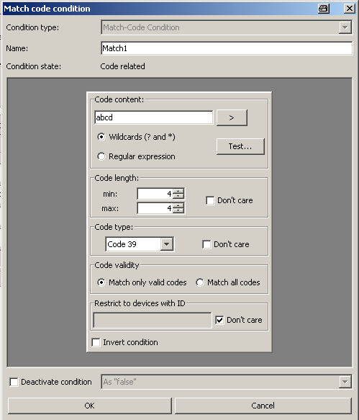
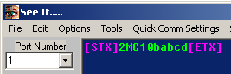

Example #2:

use Match1 set to content "12345678", save temporarly, Code ID= *, so don’t care

Data using See-It: Result in Sopas:
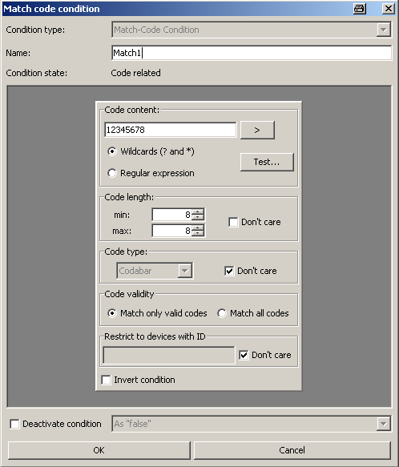
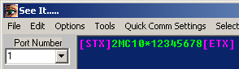

Handling of variables from type “Real” and “LReal”:

In Sopas / CLV 6xx some variables are defenid as type “Real” and “LReal”.
This is an Floating-Point format which is defined in IEEE-754.
The format contain a sign, the exponent and a mantisse.
For more details see IEEE 754 Specification.

Real IEEE-754 single precision (32 bit) (float)
LReal IEEE-754 double precision (64 bit) (double)

Examples:
- Min reading angle of CLV 6xx: RCMinCP
Dec= 15.0 == 41700000 as hex-value
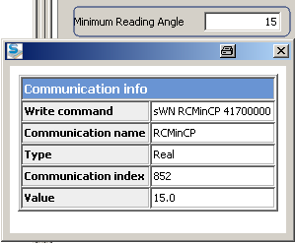

- Max reading angle of CLV 6xx: RCMaxCP:
Dec= 85.0 == 42AA0000 as hex-value
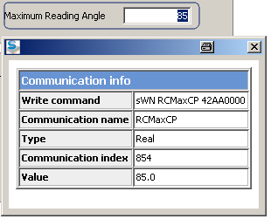

More informations about this format:
http://de.wikipedia.org/wiki/IEEE_754

Converter for this format:
http://www.h-schmidt.net/FloatApplet/IEEE754.html
Example: Type in 15 + Enter and you get the hex value: 41700000
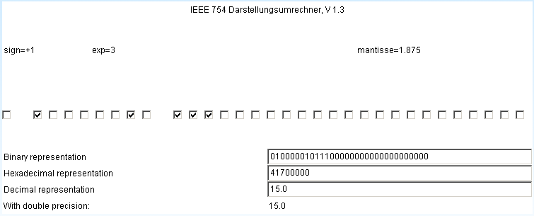

http://babbage.cs.qc.edu/IEEE-754/Decimal.html
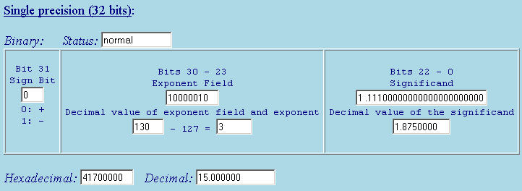

Beispiele:

Dec: Hex:
0 00000000
15 41700000
49.8 42473333
50 42480000
65 42820000
85 42AA0000
100 42C80000

